Health Questionnaire

Client Name __________________________________________________________________

Address _____________________________________________________________________

Phone (Home) _________________________ (Cell) __________________________________

Age __________ DOB ___________________

Current Weight _________ Weight six months ago _________ One year ago __________

Would you like your weight to be different? __________________________________________

Relationship Status __________________ Children? ______________________

Occupation ___________________________________ How many hours/week ____________

Has your doctor ever said that you have a heart condition and that you should only do physical activity recommen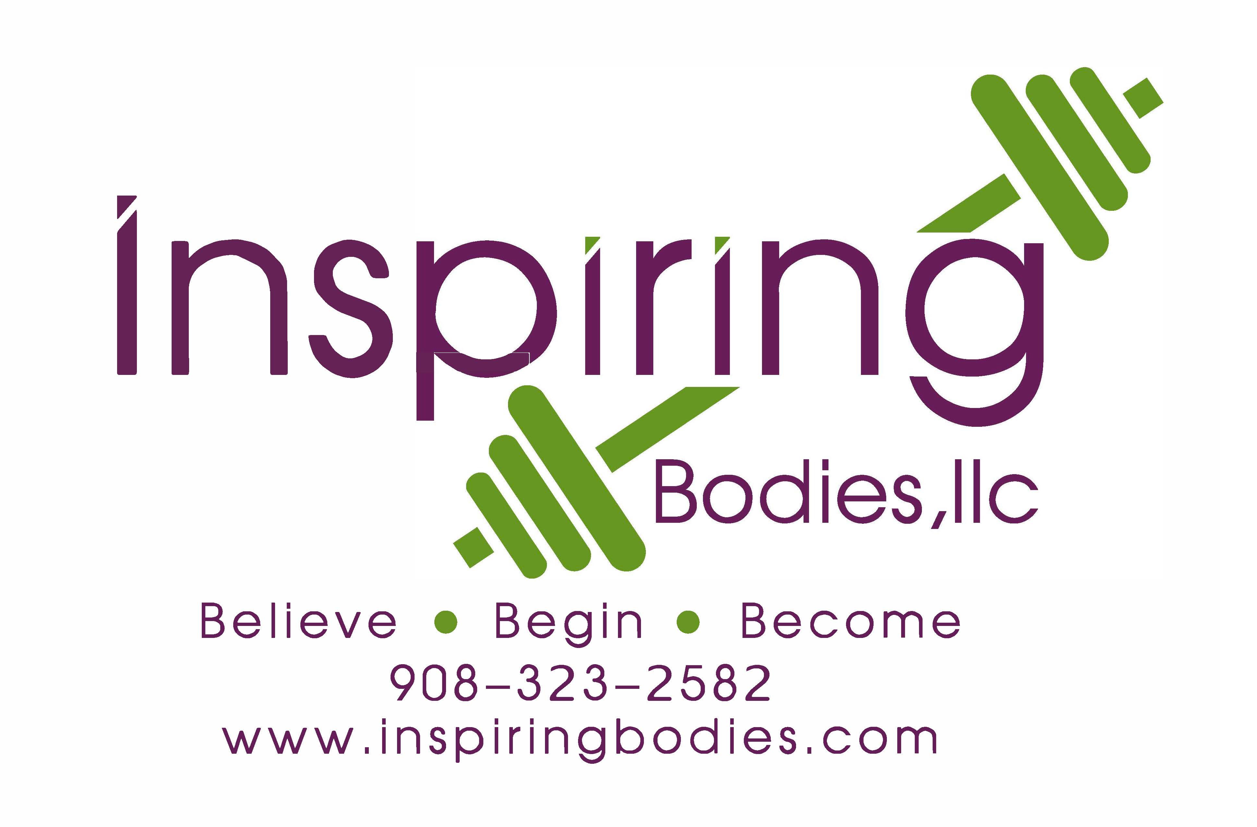ded by a doctor? ________________________________________________

*Do you feel pain in your chest when you do physical activity? ___________________________

*In the past month, have you had chest pain when you were *not* doing physical activity? ___________________________

*Do you lose your balance because of dizziness or do you ever lose consciousness? ___________________________

*Do you have a bone or joint problem that could be made worse by a change in your physical activity? _____________________________________________________________________

*Is your doctor currently prescribing drugs (for example, water pills) for your blood pressure or a heart condition? _______________________________________________________________

*Do you know of any other reason why you should not do physical activity? ____________________________________________________________________________

Do you experience high levels of stress during the course of any given day? If so, please explain

____________________________________________________________________________

How do you handle high levels of stress? ___________________________________________

Do you sleep well? _____________________ Number of hours you sleep _________________

What time do you wake up in the AM? ____________ Do you sleep through the night? _______

How is your digestion? _________________________________________________________

Do you ever experience Constipation/ Diarrhea? _____________________________________

Do you suffer from any allergies? _________________________________________________

Do you take any vitamins and/or medications? _______________________________________

How is the health of your father? __________________________________________________

How is the health of your mother? _________________________________________________

Have you ever had any serious illness/ hospitalizations/ injuries? If so, please date __________

____________________________________________________________________________

Do you drink coffee, smoke cigarettes, or have any other addictions? If so, please explain

____________________________________________________________________________

Are there any other therapies with which you are currently involved? (acupuncture, massage therapy, psychiatrist) If yes, please list _____________________________________________

____________________________________________________________________________

What role does exercise play in your life? ___________________________________________

____________________________________________________________________________

What percentage of your food is home-cooked? _________%

Where do you buy your food/eat out at _____________________________________________

____________________________________________________________________________

What is your chief health concern? ________________________________________________

____________________________________________________________________________

Any other concerns? ___________________________________________________________

What are three fitness/health goals you’d like to achieve in 2020?

1. _________________________________________________________________________
2. _________________________________________________________________________
3. _________________________________________________________________________

What is your favorite sport, and/or activity? __________________________________________

What is one intention you’d like to set during your journey with us? _______________________

____________________________________________________________________________

What is your version of “the perfect day”? Please describe _____________________________

____________________________________________________________________________

____________________________________________________________________________

Client Signature: __________________________________________ Date: ____/____/____

*If you answered YES to any of the (*) questions, you must first obtain a Dr. note before beginning any exercise program designed by Inspiring Bodies Fitness & Nutrition, LLC

**INFORMED CONSENT**

**NOTICE:** ALL NOTICES TO INSPIRING BODIES LLC HEREUNDER SHALL BE MAILED (CERTIFIED OR REGISTERED, RETURN RECEIPT REQUESTED) TO 271 QUAKERTOWN ROAD, PITTSTOWN NJ 08867.

BUYER’S ACKNOWLEDGEMENT AND ASSUMPTION OF RISK AND FULL RELEASE FROM LIABILITY OF INSPIRING BODIES LLC: BUYER ACKNOWLEDGES THAT TRAINING PROGRAMS PURCHASED HEREUNDER INCLUDE PARTICIPATION IN STRENUOUS PHYSICAL ACTIVITIES, INCLUDING BUT NOT LIMITED TO HEART ATTACKS, MUSCLE-STRAINS, PULLS OR TEARS, BROKEN BONES, SHINS SPLINTS, HEAT PROSTRATION, KNEE/LOWER BACK/FOT INJURIES AND OTHER ILLNESSES, SORENESS, OR INJURY HOWEVER CAUSED, OCCURRING DURING OR AFTER CLIENTS PARTICIPATION IN THE PHYSICAL ACTIVITIES. BUYER FURTHER ACKNOWLEDGES THAT RISKS INCLUDE, BUT ARE NOT LIMITED TO, INJURIES CAUSED BY THE NEGLIGENCE OF AN INSTRUCTOR OR OTHER PERSON, DEFECTIVE OR IMPROPERLY USED EQUIPMENT, OVER-EXERTION OF A BUYER, SLIP AND FALL BY A CLIENT, OR AN UNKNOWN HEALTH PROBLEM OF A CLIENT.

BUYER AND CLIENT AGREE TO ASSUME ALL RISK AND RESPONSIBILITY INVOLVED WITH PARTICIPATION IN THE PHYSICAL ACTIVITIES. BUYER AND CLIENT AFFIRMS THAT CLIENT IS IN GOOD PHYSICAL CONDITION, AND DOES NOT SUFFER FROM ANY DISABILITY THAT WOULD PREVENT OR LIMIT PARTICIPATION IN THE PHYSICAL ACTIVITIES. BUYER AND CLIENT ACKNOWLEDGE PARTICIPATION WILL BE PHYSICALLY AND MENTALLY CHALLENGING, AND BUYER AND CLIENT AGREE THAT IT IS THE RESPONSIBILITY OF THE BUYER AND CLIENT TO SEEK COMPETENT MEDICAL OR OTHER PROFESSIONAL ADVICE, REGARDING ANY CONCERNS OR QUESTIONS INVOLVED WITH THE ABILITY OF CLIENT TO TAKE PART IN INSPIRING BODIES LLC PHYSICAL ACTIVITIES BY SIGNING THIS AGREEMENT. BUYER AND CLIENT ASSERT THAT CLIENT IS CAPABLE OF PARTICIPATING IN THE PHYSICAL ACTIVITIES. BUYER AND CLIENT ASSUME ALL RISK AND RESPONSIBILITY FOR NOT EXCEEDING HIS/HER PHYSICAL LIMITS.

BUYER AND CLIENT, ON BEHALF OF CLIENT, HIS/HER HEIRS, ASSIGNS NEXT OF KIN, AGREES TO FULLY RELEASE INSPIRING BODIES LLC (AS WELL AS ANY OF ITS OWNERS, EMPLOYEES, OR OTHER AUTHORIZED AGENTS, INCLUDING INDEPENDENT CONTRACTORS) FROM ANY AND ALL LIABILITY, CLAIMS, AND/OR LITIGATION RESULTING FROM TRAINING PROGRAMS AND THE PHYSICAL ACTIVITIES, EVEN IF CAUSED BY THE NEGLIGENCE, GROSS NEGLIGENCE, INTENTIONAL ACTS OR OMISSIONS AND/OR ANY OTHER TYPE OF FAULT OF INSPIRING BODIES LLC IT’S OWNERS, EMPLOYEES, OR OTHER AUTHORIZED AGENTS, INCLUDING INDEPENDENT CONTRACTORS.

THE PARTY AGREES TO BE BOUND BY THE TERMS OF THIS AGREEMENT IN CONSIDERATION FOR THE MUTUAL PROMISES AND BENEFITS TO BE REVIVED BY THEM, THE ADEQUACY AND SUFFICIENCY OF WHICH THEY ACKNOWLEDGE.

Any Personal Training Package or Challenge purchased in 2020 will automatically be considered active at time of signing (or online signing) and until cancelled as described in our cancellation policy. Failure to comply with program guidelines can result in program termination at any time by Inspiring Bodies. Refunds: No refunds shall be issued for any services purchased. As this is a special program, it does not qualify for any guarantee. Media: I hereby grant Inspiring Bodies permission to interview me and/or use my likeness in photograph(s)/video in any of its publications and in any and all other media, whether now known or hereafter existing, controlled by Inspiring Bodies, in perpetuity, and for other use by Inspiring Bodies. I will make no monetary or other claim against Inspiring Bodies for the use of photograph(s)/video. I certify that I have fully read and understand the terms of this Agreement and will comply with the contents herein.

Full Name _________________________________________________________

Address ___________________________________________________________

__________________________________________________________________

Phone _________________________________________________

Email __________________________________________________

Client Signature ____________________________________________________

Date _____/_____/_____

*PLEASE make sure to follow our Cancellation Policy of 24 hours notice if you do not wish to be charged for your session. Every client MUST call our studio phone at Inspiring Bodies to cancel, or change appointment times. All appointments can be scheduled or rescheduled remotely, when necessary. Our number is (908) 323-2582.

**COVID-19 Waiver:**

Assumption of the Risk and Waiver of Liability Relating to Coronavirus/COVID-19.

The novel coronavirus, COVID-19, has been declared a worldwide pandemic by the World Health Organization. COVID-19 is extremely contagious and is believed to spread mainly from person-to-person contact. As a result, federal, state, and local governments and federal and state health agencies recommend social distancing and have, in many locations, prohibited the congregation of groups of people.

Inspiring Bodies Fitness & Nutrition, LLC has put in place preventative measures to reduce the spread of COVID-19; however, Inspiring Bodies Fitness & Nutrition, LLC cannot guarantee that you will not become infected with COVID-19. Further, attending Inspiring Bodies Fitness & Nutrition, LLC could increase your risk of contracting COVID-19.

By signing this agreement, I acknowledge the contagious nature of COVID-19 and voluntarily assume the risk that I may be exposed to or infected by COVID-19 by Inspiring Bodies Fitness & Nutrition, LLC and that such exposure or infection may result in personal injury, illness, permanent disability, and death. I understand that the risk of becoming exposed to or infected by COVID-19 at Inspiring Bodies Fitness & Nutrition, LLC may result from the actions, omissions, or negligence of myself and others, including, but not limited to, Inspiring Bodies Fitness & Nutrition, LLC employees, volunteers, and program participants and their families.

I voluntarily agree to assume all of the foregoing risks and accept sole responsibility for any injury to myself, including, but not limited to: personal injury, disability, death, illness, damage, loss, claim, liability, or expense, of any kind, that I may experience or incur in connection with my attendance at Inspiring Bodies Fitness & Nutrition, LLC. On my behalf, I hereby release, covenant not to sue, discharge, and hold harmless Inspiring Bodies Fitness & Nutrition, LLC it’s employees, agents, and representatives, of and from the Claims, including all liabilities, claims, actions, damages, costs or expenses of any kind arising out of or relating thereto. I understand and agree that this release includes any Claims based on the actions, omissions, or negligence of Inspiring Bodies Fitness & Nutrition, LLC, its employees, agents, and representatives, whether a COVID-19 infection occurs before, during, or after participation Inspiring Bodies Fitness & Nutrition, LLC and it’s program.

Signature_______________________________________________________

Print Name______________________________________________________